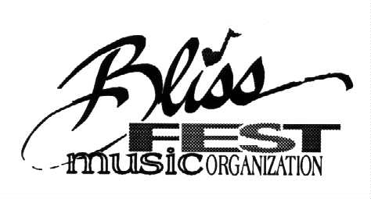
522 Liberty St., Petoskey, MI 49770
231/348-7047 www.blissfest.org

Blissfest 2018 Minor Release Form
Due by June 15th, 2018

I,_______________________ (Parent of Teen) am the parent or legal guardian of ______________________(Teen), and I hereby grant permission for my minor child to participate in The Blissfest Music Festival under the care of _____________________________.(Non- Parent Adult Guardian)

I do assume any and all risks that might be associated with the activities that my child may be involved in at the Festival. I release the Blissfest Music Organization from any and all liability due to any accident or injury that may result during my child’s participation in the camp.
I understand that if my child does not follow acceptable behavior, as established by the Blissfest Organization and my child is expelled, I will be responsible for returning my child home.
My child will attend The Blissfest Festival under the guardianship of: __________________________________.
Contact information(Temporary Guardian): phone:________________________ email:___________________________
I hereby grant permission for first aid to be administered to my child in the event that it becomes necessary. I also grant the guardian authority to act in my place and with the same authority as myself during the course of the festival event, including the right to approve or decline emergency or other medical care in the event that I cannot be reached by festival staff. I request that in my absence, my child be admitted to any hospital or medical facility for diagnosis and treatment if deemed necessary by the guardian. I authorize physicians and nurses to perform any necessary diagnostic procedures, treatment procedures and operative procedures on my child. I assume financial responsibility for all medical treatment that is provided.
Blissfest staff and medical personnel should be aware of the following medical conditions and known allergies, and/or medications currently taken by my child (also see attached health history if needed):_________________

Parent(s) phone numbers Parent’s Signature______________ _____________Date________Phone___________

PARTICIPANT AGREEMENT
I agree to follow the instructions and directions given to me by the staff and my guardian.

(Signature of participant teen) _____________________ (date)_____________

This release form and any attached health history as applicable must be returned by June 15th 2018 to:

Blissfest, c/o Sarah Reinfelder, 522 Liberty St., Petsokey, MI 49770 Notarize Here If Applicable

